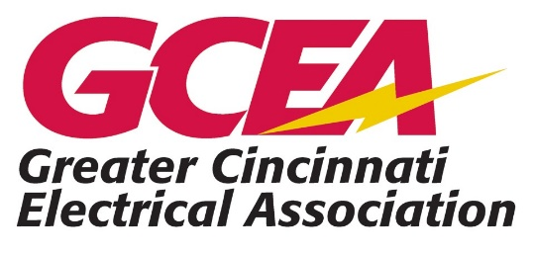
2027
“John Schoenfeld” $600 Tool Bag Award Application
Application

Purpose: Assist in attracting and retaining workers for the future of the electrical industry.

- Qualification Requirements. Applicant must be one of the following:
  - Enrolled as an apprentice at the IBEW or IEC…or graduating senior at local vocational school with co-op or starting position at a GCEA member company.
  - An employee of a GCEA member company not affiliated with the IEC or IBEW who has completed one full year of full-time employment as an electrician.
  - A son, daughter, grandson, or granddaughter of a member in good standing of the GCEA who has completed one full year of full-time employment as an electrician by a licensed electrical company.
- Selection
  - Applicants will be judged based on Work Ethic, Electrical Industry Aptitude, Character, Essay, and any other Relevant Information.
- Award
  - The amount of each award is $600. The award is to be applied to purchase of additional tools required for the trade. Payment of the award will be made by check addressed to both the recipient and the employer for assistance of tool procurement.
  - All award winners will be notified by the Scholarship Committee of the GCEA by
May 15, 2027.
  - Successful candidates will be recognized and presented their awards at the GCEA Golf Outing and dinner on June 14, 2027, at the Aston Oaks Golf Course in North Bend, OH. This golf outing funds the GCEA Edward W. Mohr Scholarship and the John Schoenfeld Tool Bag Award.
- Required Submission Materials
  - Applicant must be nominated by their employer. Employer must submit a “Letter of Recommendation” to the GCEA.
  - Essay…on a separate piece of paper, write an essay of 150-200 words telling your plans and hopes for the near future. Why do you enjoy the trade you are in?

2027
“John Schoenfeld” $600 Tool Bag Award Application
Application

Personal Information (Please print in ink or type)
Name:
Address:
Phone:
E-Mail:
Date of Birth:

Vocational Training Program (Employer Info, IBEW, IEC, etc. if applicable)
Training:
Address:
Training Start Date: Training End Date:
Instructor/Supervisor’s Name:

Work Experience
Occupation: Employer Dates Part/Full Time

Interests/Hobbies
List Areas of Special Interest and Hobbies (Include Community and Volunteer Work)



Signature
The information on the following pages is complete and accurate to the best of my knowledge.
Signature of Applicant Date
Signature of Parent or Guardian (if Required) Date

Important Message to Applicant: Attach your letter of recommendation (use staple please) to this application form. All applications must be received in full no later than April 15, 2027.
Website: www.gcea.org
Email to: info@gcea.org
Mail to: GCEA
Attn: Tool Bag Award Committee
PO Box 58183
Cincinnati, OH 45258-0183

